Name: 6500°K  Fill: Argon/Mercury  Intensity Scale: 3  Description: Standard Daylight | 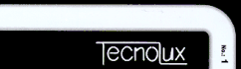
Name: Blanc jour  Fill: Argon/Mercury  Intensity Scale: 3  Description: Cool daylight 7500°K | 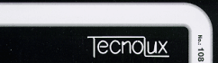
Name: 4500°K  Fill: Argon/Mercury  Intensity Scale: 3  Description: Standard Cool White | 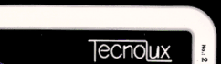
Name: Special White 5000°K  Fill: Argon/Mercury  Intensity Scale: 2  Description: Cool white blend with highest color rendition values. Color Rendition Index (CRI) value of approximately 96-98. | 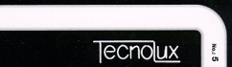
Name: 4500°K Triphosphor  Fill: Argon/Mercury  Intensity Scale: 3  Description: Triphosphor cooltone, with high color rendering properties and light intensity. Color Rendition Index (CRI) value of approximately 90. | 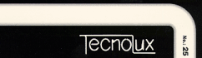
Name: Natural White  Fill: Argon/Mercury  Intensity Scale: 2  Description: Special blends to beautify the appearance of red objects. | 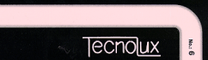

Name: 3500°K  Fill: Argon/Mercury  Intensity Scale: 3  Description: Standard Medium Warm White. | 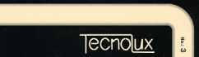
Name: 2800°K  Fill: Argon/Mercury  Intensity Scale: 3  Description: Standard Warm White. | 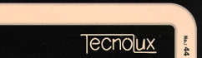
Name: Warm tone 2800°K  Fill: Argon/Mercury  Intensity Scale: 4  Description: Triphosphor Warm tone-resembles light emitted from incandescent lamps, with high color rendering properties and light intensity. Color Rendition Index (CRI) value of approximately 86. | 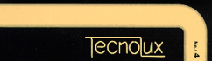
Name: 3500°K Triphosphor  Fill: Argon/Mercury  Intensity Scale: 4  Description: Triphosphor warm white, designed to match the color and light intensity of halogen lighting. Color Rendition Index (CRI) value of approximately 86. | 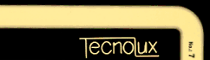
Name: Ruby Red Argon  Fill: Argon/Mercury  Intensity Scale: 3  Description: Rich saturated red. | 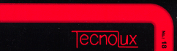
Name: Cobalt Blue Uncoated Filled with Neon  Fill: Neon  Intensity Scale: 1  Description: Deep maroon, with a hint of blue. | 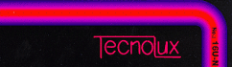
Name: Purple  Fill: Argon/Mercury  Intensity Scale: 1  Description: Soft, royal purple with a velvet texture. | 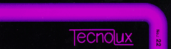
Name: Violet  Fill: Argon/Mercury  Intensity Scale: 3  Description: Light purple. Designed to reduce fabrication problems associated with the traditional purple. | 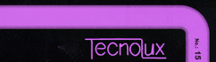

Name: Magenta  Fill: Argon/Mercury  Intensity Scale: 4  Description: Unique and beautiful purple-red. | 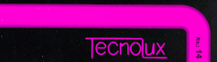
Name: Citrus Orange  Fill: Argon/Mercury  Intensity Scale: 4  Description: Bright, brilliant orange. | 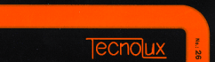
Name: Soft Orange  Fill: Neon  Intensity Scale: 3  Description: Uncoated orange filled with neon gas. | 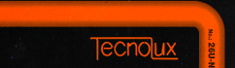
Name: 4500°K  Fill: Neon  Intensity Scale: 3  Description: Warm Orange. | 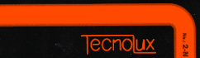
Name: Uncoated Ruby  Fill: Neon  Intensity Scale: 3  Description: Soft red containing a touch of orange. | 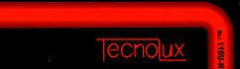
Name: Ruby Red Neon  Fill: Neon  Intensity Scale: 3  Description: Rich saturated red. | 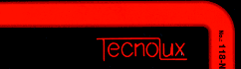
Name: Green  Fill: Neon  Intensity Scale: 3  Description: Yellow Orange | 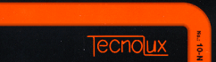
Name: Pink  Fill: Argon/Mercury  Intensity Scale: 3  Description: Beige flesh tone. | 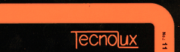

Name: Salmon Rose  Fill: Argon/Mercury  Intensity Scale: 3  Description: Rich pink orange. | 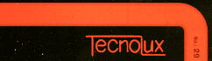
Name: Special Red  Fill: Argon/Mercury  Intensity Scale: 3  Description: Designed to optimize the lumen output of channel letter illuminated signs covered with red plastic. | 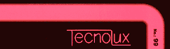
Name: Coral Rose  Fill: Argon/Mercury  Intensity Scale: 4  Description: Extremely stable tropical color with a long-life color consistency. More stable than traditional pink achieved by blue tubing filled with neon gas. | 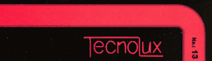
Name: Blue  Fill: Neon  Intensity Scale: 3  Description: Hot Pink. | 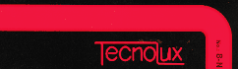
Name: Cobalt Blue  Fill: Argon/Mercury  Intensity Scale: 3  Description: Fully saturated primary blue. The "ultimate" blue. | 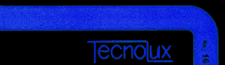
Name: Cobalt Blue Uncoated Filled with Argon-Mercury  Fill: Argon/Mercury  Intensity Scale: 1  Description: Soft midnight blue--a low light output, serene blue. | 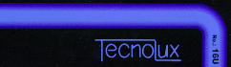
Name: Blue  Fill: Argon/Mercury  Intensity Scale: 3  Description: Soft Powder Blue | 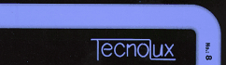

Name: Super Blue  Fill: Argon/Mercury  Intensity Scale: 4  Description: Intense blue, with high lumen output and super rich color. | 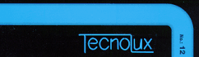
Name: Aquamarine  Fill: Argon/Mercury  Intensity Scale: 3  Description: Bright light blue with a whisper of green. | 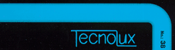
Name: Sky Blue  Fill: Argon/Mercury  Intensity Scale: 4  Description: Resembles clear tropical sea color. | 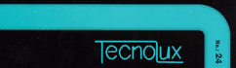
Name: Super Turquoise  Fill: Argon/Mercury  Intensity Scale: 4  Description: Unique monochrome phosphor creating a very intense rich turquoise. High lumen output. | 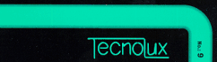
Name: Traffic Light Green  Fill: Argon/Mercury  Intensity Scale: 4  Description: Brightest green offered. Contains hint of blue. Bright and stable color consistency and long life span (lumen maintenance). | 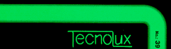
Name: Emerald Uncoated  Fill: Argon/Mercury  Intensity Scale: 2  Description: Soft teal green. | 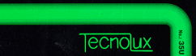
Name: Emerald  Fill: Argon/Mercury  Intensity Scale: 3  Description: Bright forest green, rich and fully saturated. | 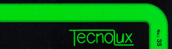
Name: Green  Fill: Argon/Mercury  Intensity Scale: 4  Description: Traditional neon green. | 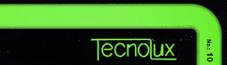

Name: Lite Green  Fill: Argon/Mercury  Intensity Scale: 3  Description: Brilliant lime green. | 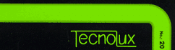
Name: Lite Green Uncoated  Fill: Argon/Mercury  Intensity Scale: 2  Description: Beautiful spring grass color. | 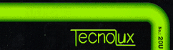
Name: Uncoated Gold  Fill: Argon/Mercury  Intensity Scale: 2  Description: Soft electric green--a lime color. | 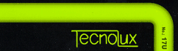
Name: Gold  Fill: Argon/Mercury  Intensity Scale: 3  Description: Warm commercial gold. | 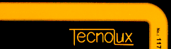
Name: Pineapple  Fill: Argon/Mercury  Intensity Scale: 4  Description: Luscious and fruity yellow which uses a single phosphor compound to reduce discoloration that may occur with traditional double coated tubing. | 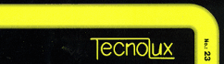
Name: Lemon Yellow  Fill: Argon/Mercury  Intensity Scale: 4  Description: Brilliant cool yellow. | 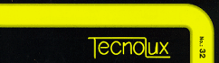
Name: Novial Gold  Fill: Argon/Mercury  Intensity Scale: 3  Description: Rich fully-saturated yellow-gold. | 